Polynomial Project

Project Assignment:
1. Be sure to include all parts.
2. You will need to do some mathematical calculations in order to complete all the parts! All work must be shown to receive credit.
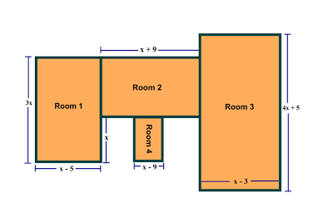
Project Details:
You are building a house with the above floor plan.
1. Perform the appropriate operations on the polynomial dimensions to determine the perimeter of each room and entire house in terms of x.

2. Determine the area of the each room and entire house in term of x.

Rubric:
- Perimeter (Total of 10 points):
The perimeter of each room and the entire house is worth 2 points
- Area (10 points)
The area of each room and the entire house is worth 2 points

Name: ______________________ Name: ________________
Date: _______________ Block: ________________

Room | Perimeter
Room 1
Room 2
Room 3
Room 4
Entire house

Room | Area
Room 1
Room 2
Room 3
Room 4

Homework: 1-4; Name: _______________ Date: ________

Definitions: Look up the following definitions for the fowling properties and provide an example for each:

- Distributive property of equality: _________________________________________
Example: ___________________________________________________

- Addition property if equality:
_________________________________________
Example: ___________________________________________________

- Commutative property if equality:
_________________________________________
Example: ___________________________________________________

- Associative property if equality:
_________________________________________
Example: ________________________________________________

- Answer the following question:
When solving the equation $4\left(3x^{2}+2\right)-9=8x^{2}+7$Emily wrote computations $4\left(3x^{2}+2\right)=8x^{2}+16$ as her first step. Which property justifies Emily’s first step?
(1) addition property of equality
(2) commutative property of addition
(3) multiplication property of equality
(4) distributive property of multiplication over addition

Blast from the past: Find the product:
1. $-6\left(x+4\right)=$ 2. $y\left(y^{3}+4\right)=$

3. $2y^{2}\left(5y-3\right)=$ 4.

5. Find the perimeter for the following diagrams:
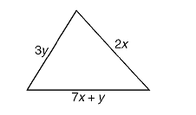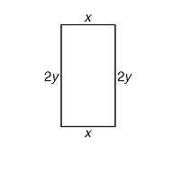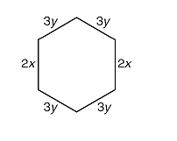

6. Back to Adding a Subtracting: Combine the following terms:
$A) 3y+4x-6y$ $B) 3y-(4x-6y)$

